Community Foundation News


No. 79 January 6, 2007

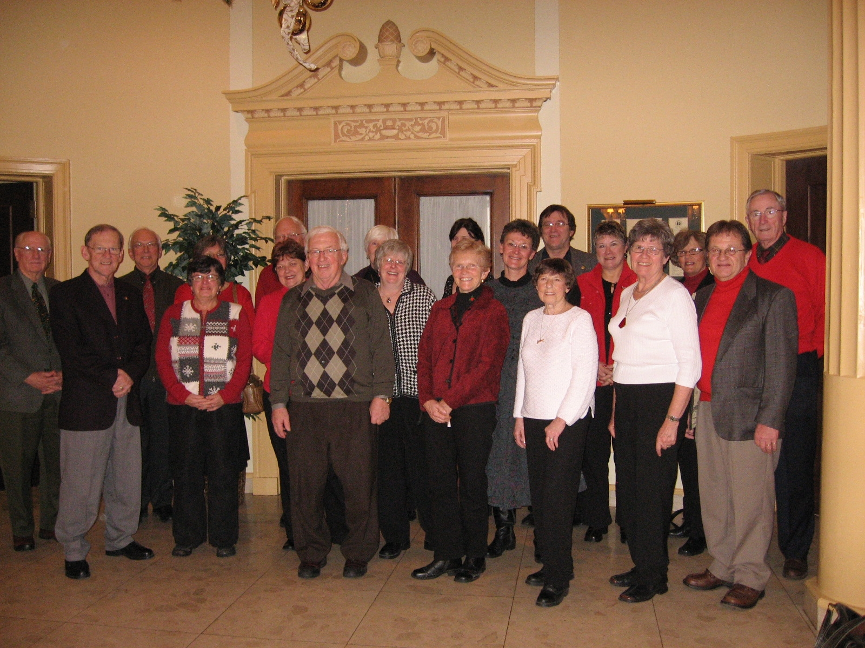
Foundation Family at our Annual Christmas Luncheon
December 12, 2007 at the Charlottetown Hotel

- GREETINGS to readers scattered across the continent most of whom have an Island connection

- THANKS to the Foundation family, Directors, staff, volunteers and donors for another good year

- BEST WISHES to all for 2008
Don Glendenning
Editor

PEACE JOY GOOD WILL LOVE

